### 

*E-Tender For*

*Fabrication, Supply and Commissioning of Boiler Chimney*

***JABALPUR SAHAKARI DUGDH SANGH MYDT***

**OFFICE & WORKS:** KARONDA NALA,IMALIA, JABALPUR- 483220, M.P., (INDIA)

**PHONE** **:** 9406900452

**E-mail:** jdssanchipurchase@gmail.com





**JABALPUR SAHAKARI DUGDH SANGH MARYADIT**

**OFFICE & WORKS:** KARONDA NALA,IMALIA, JABALPUR- 483220, M.P, (INDIA)

**PHONE** **:** 9406900452

**E-mail:** jdssanchipurchase@gmail.com

|  |  |  |
| --- | --- | --- |
| TENDER DOCUMENTS | | |
| **Schedule – I** | : | General Terms and Conditions |
| **Schedule – II** | : | Design and Technical Specification |
| **Schedule – III** | : | Price Bid |
| **Schedule – IV** | : | Technical specification of tender form. |
| **Tender Reference** | : | JSDS/ENGG./2020-21/_30______  Dated-__22_/__07_/2020 |
| **Last Date & Time of online purchase of Tender** | : | Date 11-8-2020 Up to Time 04:00 PM |
| **Last Date & Time for online Submission of filled Tender** | : | Date- 12-8-2020 Up to Time 04:00 PM |
| **Date & Time for opening of Tenders** | : | Date- 13-08-2020 on Time 04:00 PM |
| **Place of Submission & opening of Tender** | : | Jabalpur Sahakari Dugdh Sangh Maryadit  KARONDA NALA,IMALIA, JABALPUR- 483220, M.P., (INDIA) (M.P.) |
| **Address for Communication** | : | The Chief Executive Officer  Jabalpur Sahakari Dugdh Sangh Maryadit  KARONDA NALA,IMALIA, JABALPUR- 483220, M.P., (INDIA) (M.P.) |
| **Cost of Tender Document** | : | Rs. 1000/- only (Rupees Five Hundred only) to be paid online. |

**Note:** The tenderer should read well each & every page of this document bunch and

Signature with seal/stamp be put on each page at bottom.

**CHIEF EXECUTIVE OFFICER**

***Schedule I***

***General Terms & Conditions***

Jabalpur Sahakari Dugdh Sangh Maryadit, Jabalpur invites Online Tenders from reputed and experienced Agencies/Firms for Fabrication, Supply, Erection and Commissioning of 30 meters. Long Boiler Chimney at Dairy Plant – Jabalpur, and to obtain boiler operational certificate from competent authority.

**1 *Tender Submission:-***

* 1. The tender should be submitted online not later than 11/08/2020 up to 04:00 PM.
  2. Tenders received by Telegram/Fax/E-mail will not be considered.
  3. Individual signing the tender/other connected documents must specify whether he has signed as:

1. The sole Proprietor of the firm or duly authorized representative of such proprietor.
2. A partner of the firm, if it is partnership firm in which case he must have authority to refer to the arbitration disputes concerning the business of the partnership either by virtue of the partnership deed or by power of attorney. A copy of the partnership deed shall be attached with the tender.
3. Authorized signatory in case of Registered/Limited Company/Organization.
   1. The tenders will be accepted and will be opened as per schedule given in first Page of this document.
   2. The tenderers should clearly state in their offers the Address, Telephone no., GST No., E-mail ID and Mobile no. Any change in address should immediately be notified to the Chief Executive Officer, JSDS and Correspondence thereafter will be made at the changed address.
   3. Tenderer Validity:- 30 days from the date of opening of Financial bid.

**2 *Earnest Money Deposit:-***

2.1 The supplier shall deposit the Earnest Money Amount (EMD) as mentioned in Bid invitation and General information’s ,payable online during uploading of the tender at <https://mptender.gov.in> only. EMD will not be accepted in cash at Finance section JSDS or in

the demand draft. Bidder shall upload scan copy of the transaction no./ receipt obtained

through online payment as proof of successful payment. In case the supplier withdraws his offer during the validity period, after placement of order, the EMD amount shall be forfeited.

|  |  |  |  |
| --- | --- | --- | --- |
| **S.No.** | **Items/Equipment** | **Quantity** | **EMD (in Rs.)** |
| 01. | Fabrication, Supply and Commissioning of Boiler Chimney | 1 No./Job | Rs. 20,000.00  (Rs. Twenty Thousand only) |

2.2 Any Tender which is not accompanied by earnest money deposit are liable to be rejected.

The earnest money deposit of the successful tenderer will be released on completion of

supply/installation work as the case may be within the stipulated period. For under

performance guarantee this EMD will be treated as security deposit.

2.3 No interest will be paid for the earnest money during the period it lies in deposit with the

JSDS Jabalpur.

**3 *Prices:-***

3.1 Prices offered by the tenderers should be firm and free from all escalation. Rate approval

shall be communicated within 20 days of opening of tender.

3.2 The tenderer should quote price FOR- Dairy Plant, Jabalpur inclusive of loading/unloading

/labour charges all taxes.

3.3 The tenderer should clearly specify whether rates quoted are inclusive or exclusive of GST.

***4 Mode of Despatch:-***

4.1 The material to be supplied shall be dispatched to the site by Road Transport under intimation to the Purchaser and the Consignee. Depending upon the type of material, the supplier shall have to carry out proper packing to avoid damage/breakage during transit.

***5 Insurance:-***

The Supplier shall arrange transit insurance.

***6 Payment:-***

60% on receipt of material at site.

30% after 15 days of completion of work.

10% after 1 Year of completion of work.

***7 Delivery and Commissioning Period:-***

45 days from the date of receipt of confirmed order

***8 Liquidated Damages:-***

Once firm delivery dates for the supply, erection and commissioning of the units are established they shall be strictly adhered to and this forms the essence of the contract. In case they not follow, the schedule A supply Jabalpur Sahakari Dugdh Sangh reserves the Rights **either to cancel the order and make alternative purchases at the risks** and expense of the defaulting supplier or to charge an appropriate amount as liquidated damages on the sole discretion of Chief Executive Officer. In case of delay the penalties may be imposed as under and will be deducted from the supplier’s bill.

Duration of Delay : Penalty

Up-to 15 days : 2% cost of the unit

Between 16 to 30 days : 5% cost of the unit

Above 30 days : up-to 10% cost of the unit

***9 Warranty/Guarantee:-***

The Supplier shall guarantee to replace without any extra cost the item supplied if found defective/broken due to bad designing, workmanship for substandard material within 01 week from the date of supply.

***10 Warfare/Demurrage:-***

Warfare/Demurrage etc., if any on account of incorrect or delayed dispatch of material or documents shall be the responsibility of supplier and will be recovered from his bill.

***11 Termination of contract:-***

For any act of omission of a unit that brings the Jabalpur Sahakari Dugdh Sangh Maryadit Jabalpur into dispute, Jabalpur Sahakari Dugdh Sangh Maryadit Jabalpur Shall competent to debar/blacklist the unit form further business with Jabalpur Dugdh Sangh Jabalpur, and sister concerns.

***12 Drawing and specification:-***

Rates should be quoted for the specification given in the tender document, where ever no specification are given in the tender document, detailed specification of the articles and its components should be mentioned by the tenderer.

***13 Final Authority/Arbitration:-***

13.1 In case of any dispute regarding the contract the matter shall be referred for arbitration under the Arbitration Act. Chairman, Jabalpur Sahakari Dugdh Sangh Jabalpur shall be the arbitrator, whose decision shall be final and binding on both the parties. Venue of arbitration will be Jabalpur.

13.2 For all disputes, the jurisdiction shall always be Jabalpur and No Court outside Jabalpur shall have any jurisdiction.

Seal & Signature of Tenderer

***Schedule II***

***Design and Technical Specification***

***1 Functional Requirement-***

Commonly use for 01Nos. of Boilers Capacity 2.0 M.T.

***2 Specification -***

2.1 Chimney design as per IS6533,Material of construction of Chimney Plate IS2062

GR B, Nut and bolt for flange joint SA193,GR-B7 & SA193,GR.2H

2.2 Conical Portion Made by 10MM thick plate (1600mm X933m X12Mtr long)

2.3 Conical Portion Made by 8MM thick plate (933mm X600m X 6Mtr long).

2.4 Straight Portion Made by 8MM thick plate (600mm X6 Mtr long)

2.5 Straight Portion Made by 6MM thick plate (600mm X6 Mtr long)

2.6 Base Plate-25Mm Thick plate

2.7 Chair Ring-25mm thick plate

2.8 Flange 2 Nos pair in 16 MM thick plate with 16MM gusset plate.

2.9 Bottom gusset plate 16 Mm thick plate.

3.0 Rib joint plate 75 X150 X10mm 6 Nos each joint.

3.1 Spiral ladder ground level to first platform.

3.2 Monkey ladder with safety cage in ISA50X50X6 from platform to top

3.3 The chimney will be provided with assess door at the bottom.

3.4 Platform at 10.5 Mtr sampling point ,at 11.5 Mtr

3.5 lightening arrestor with earthing strip (GI) 25 mm, Isolator up-to ground level.

3.6 Aviation Lamp(LED) including the 2C X1.5 sqmmCu cable up-to ground level.

3.7 Foundation Bolts M40 with nut & Check nut 24 Nos.

3.8 Template for foundation in 6 MM plate double décor with supporting pipe according

to chimney base plate and chair ring.

3.9 Internal painting with HR stack black paints 250 Deg.

4.0 External painting with HR Aluminum paints 250 Deg.

4.1 6mm. thick M.S. Cap will be provided and installed alongwith chimney as

protection from rain etc:

4.2 5Nos. of stay wire of Wire Rope should be provided.

***3 Scope of work -***

3.1 Supply, Fabrication, Erection and Commissioning of Boiler Chimney at Jabalpur Dairy

Plant, Jabalpur.

3.2 We required to use the existing chair plate of the Chimney so the new chair plate is

not required.

3.3 The tenderer has to visit once the site to take proper dimension of chimney

before filling the tender.

3.4 Tenderer has to make arrangement to dismantling of existing chimney and

shift it to scrap yard.

3.5 The connection of Chimney to Boiler, and replant of dust collection will also be in

the scope of tenderer.

Seal & Signature of Tenderer

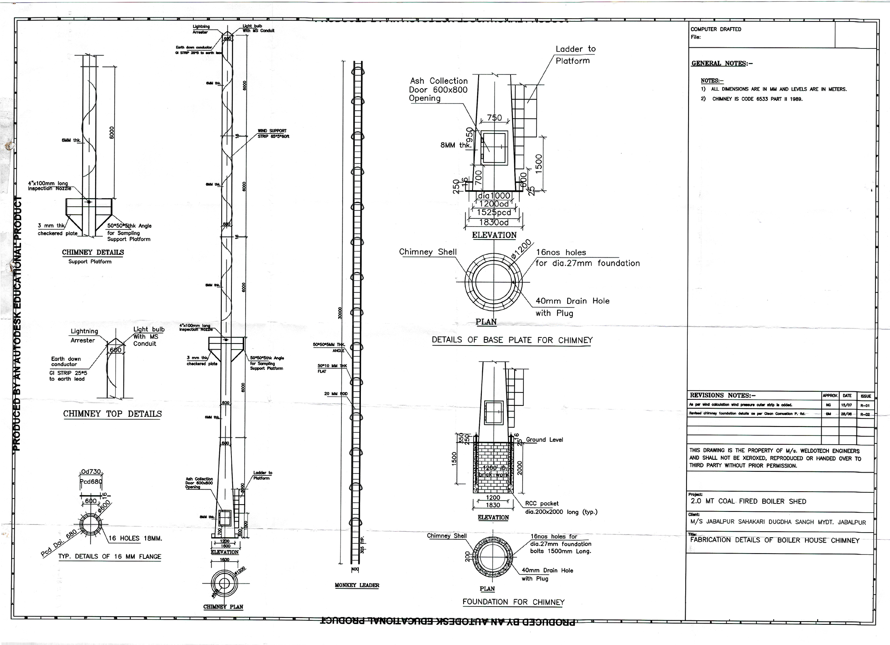

**Jabalpur Sahakari Dugdh Sangh Maryadit**

**OFFICE & WORKS:** KARONDA NALA,IMALIA, JABALPUR- 483220, M.P., (INDIA)

**PHONE** **:** 9406900452

**E-mail:** jdssanchipurchase@gmail.com

**Schedule III**

***Price Bid***

|  |  |  |  |
| --- | --- | --- | --- |
| 01. | Name of Manufacturer/Dealer/Supplier | : |  |
| 02. | Full postal address | : |  |
| 03. | Phone/Mobile/Fax No. | : |  |
| 04. | E-Mail ID | : |  |
| 05. | GSTIN NUMBER. | : |  |
| 06. | PAN No. | : |  |
| Note :- (Attach a copy of GST/PAN No. of Proprietor/Firm etc.) | | | |

**Rates Quoted**

|  |  |  |  |
| --- | --- | --- | --- |
| **S.No.** | **Item/Machine Name** | **Qty** | **Rate- FOR Destination (Jabalpur)** |
| 01. | Fabrication, Supply, Erection and Commissioning of Boiler Chimney as per schedule-II of Tender form. Rate including loading/unloading with all taxes. | 1 No./Job | Rs.  In words (Rs.__________________  ________________________Only) |

Note:- Rates should be given FOR Destination with unloading, erection and commissioning etc: where required/applicable.

**Seal & Signature of Tenderer.**

***TECHNICAL SPECIFICATION OF CHIMNEY SUITABLE FOR 2 TPH BOILER***

Type self supported chimney (conical base with straight cylindrical)

Design code IS 6533 with compatibility to MPPCB norms

Size top OD 500 mm x bottom OD 1000 mm x 30.5 mtr height

Base plate dia 1300 mm (for solid fuel fired boiler)

top OD 300 mm x bottom OD 600 mm x 30.5 mtr height

Base plate dia 900 mm (for oil/gas fuel fired boiler)

Thickness Base plate 20 & 16 mm thick (double base plate) with stiffners

Conical base 10 mm thk x10 mtr height, cylindrical shell 8 mm x

10 mtr and cylindrical Shell 6 mm thk x 10.5 mtr

MOC MS IS 2062 grade

Accessories: flanges with stiffener, plate form, step ladder, plate form

monkey ladder with safety cage, smoke sampling

Nozzle, foundation bolts, ash

Removal provision at bottom and anti Corrosive HR paint.

SCOPE OF SUPPLY: 1) Chimney – 5 pieces of 6 mtr each (base plate fitted in bottom)

2) step ladder

3) Monkey ladder with cage

4) Plate form -1 no.

5) Railing material – 1 lot

6) Paint – primer followed by HR aluminum paint.

7) lightening arrester assembly with GI flat, Aviation lamp

assembly, template, foundation bolts, HT nut bolts, gye rope

with accessories etc.

PRICE SCHEDULE:

SUPPLY OF CHIMNEY DIA 500 MM HEIGHT 30.5 METER

1) weight x rate = price + taxes + freight

2) Supply of accessories like lightening arrester assembly with GI flat, Aviation lamp assembly, template, foundation bolts, HT nut bolts, gye rope with accessories etc.. = price + taxes + freight

3) civil foundation work = price + taxes

4) chimney alignment and erection = price + taxes

5) earthing pit with material = price + taxes

Packing and forwarding – to be included in price above

Taxes – GST@ 18 % extra

Freight – to be paid and arranged by you

Transit insurance – to be paid and arranged by you

Payment terms – 60% on receipt of material at site.

30% after 15 days of completion of work.

10% after 1 Year of completion of work.

Delivery required – 30 days

Validity – 90 days.